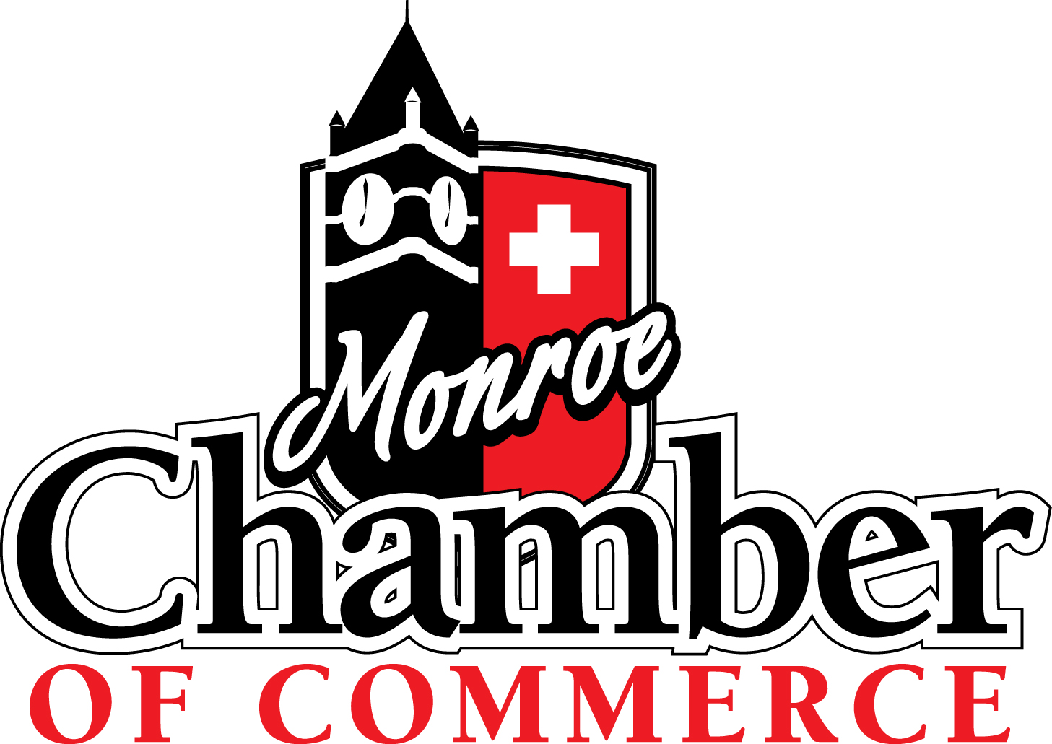

Ambassador
Handbook

2013

Dear Ambassador:

It is with a great deal of pleasure that we welcome you as an Ambassador of the Chamber.

Our mission as Ambassadors is to significantly increase membership retention by improving communications with our membership and increasing membership involvement and support of all Chamber events and activities. You will spend about four-to-five hours per month on Ambassador duties. The time and energy which you devote to your responsibilities in implementing programs will naturally affect the degree and quality of the Chamber’s 2013 Program of Work.

This manual has been compiled to furnish information which will enable you to better understand the function of the Chamber and the significance of your role. This manual will also serve as a convenient reference throughout the year as you seek information about Ambassador activities.

Thank you for your commitment and support to this year’s Ambassador Program. Together we can make the difference in fulfilling our mission of continuing to maintain a well-informed, involved, responsive, and committed membership.

Sincerely,

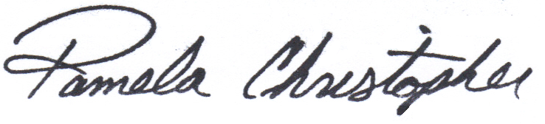
Pamela L. Christopher
Executive Director

WELCOME

Being an Ambassador offers you a unique opportunity. You will be able to meet with Chamber member decision-makers on a professional basis while helping your Chamber meet its goal of personally contacting each member each year resulting in increased membership retention.

As a volunteer Ambassador, your motivation is important to our success. Simply put, a volunteer must want to be successful and should exhibit a sincere willingness to volunteer. A positive attitude is a must.

We invite you to be proud of the fact that you are an important and welcomed member of the Chamber’s Premier Volunteer Organization.

For your involvement and efforts, you will receive recognition from your employer and the Monroe/Green County business and professional community.

You will also find out that through your Ambassador experience, you will gain numerous business contacts and share in a special fellowship with other volunteers and business leaders.

Monroe Chamber of Commerce

Mission Statement

To create an environment of business success through promotion, advocacy, connection and education. PACE

Core Values

- We operate Ethically and with Integrity
- We are Inclusive
- We treat everyone with Respect
- We are fiscally Responsible
- We strive for Excellence

WHAT IS A CHAMBER OF COMMERCE?

A Chamber of Commerce is a voluntary organization. It unites businesses, professional leaders, and firms thus creating a central agency which lends itself to improving business and building a better community.

It must be understood that a Chamber of Commerce is people. There is a place in the Chamber of Commerce efforts for all who share the desire to improve the community and the conditions under which business is conducted. It directs the energies of those who believe that a community worth living in is a community worth improving.

A Chamber of Commerce enables these people to accomplish collectively what no one of them could do individually. Its strength lies in attracting the greatest number of individuals and firms into membership, thereby creating a pool of resources from which can be drawn ideas, energy, and finances.

A Chamber of Commerce gives expression to the business person’s natural instincts to improve the market and the community of which that person is a part. Originally, its function was to protect commerce in transit, in the marketplace, and to promote the sale of goods.

Today, Chambers of Commerce have become organizations for the total community. Currently, the successful Chamber of Commerce is the one which recognizes all the factors which affect the community and adjusts its programs accordingly.

WHAT A CHAMBER OF COMMERCE IS NOT

WE ARE NOT a department of the city, county, or state government, a political body; a civic club or professional society; a social service, welfare or charitable institution, a private advertising, publicity or public relations agency.

THANK YOU TO ALL OF OUR VALUED CHAMBER AMBASSADORS!

THE AMBASSADORS
2013

ANNUAL GOAL

The Ambassador’s annual goal is to increase the retention rate of new and existing members by conducting a program of goodwill calls: Reinforcing the benefits of Chamber membership, increasing members’ knowledge about programs and services of the Monroe Chamber of Commerce, and keeping the channels of communication open between the membership and the Chamber’s Board of Directors.

PERSONAL CONTACTS

A personal monthly contact goal of five (5) are set, which can be in the form of New Member Mentoring or Member Relations calls to existing members.

MONTHLY MEETING

During the monthly Ambassador’s meetings, Ambassadors will be assigned approximately five existing member firms to call during the next month. In addition, a guest speaker will be invited from time to time to inform the Ambassadors about timely topics of interest to the business community.

Attendance is important. Any Ambassador with three unexcused absences will be dropped from the group.

**** If you cannot attend a meeting, it is your responsibility to notify
the Chamber office by calling 325-7648.

FACTS ABOUT THE AMBASSADORS

JOB DESCRIPTION
The Ambassadors are a group of knowledgeable volunteers serving in a year-round effort as the customer service representatives for the Monroe Chamber of Commerce and acting as a conduit between the Chamber and its existing and new members.

Ambassadors aid the Chamber with membership retention by making personal calls to member decision makers. Ambassadors encourage members to become involved in the Chamber and assist members in learning more about the Chamber. Ambassadors will inform and receive feedback on Chamber activities and programs.

Additional voluntary activities include serving as greeters at Business After Hours, participating in ribbon cuttings and various activities such as the Annual Golf Tournament and Annual Meeting.

MEMBERSHIP
The Ambassadors are limited to men and women whose companies (or the individual) are members in good standing in the Monroe Chamber of Commerce. Following an initial contact by Chamber staff and an orientation, recommendations are made and Ambassadors are selected.

The candidate’s current position should involve significant public exposure and allow freedom to devote the time necessary to contribute to and participate actively in Ambassador goal activities.

BENEFITS
- Enhanced career development/networking
- Increased exposure for your business
- Expanded base of contacts and clients
- Recognition for you and your firm

REQUIREMENTS
The following are activities that must be met and maintained to retain active Ambassador program participation.

- Attendance at Ambassador Orientation
- Commitment to contact the assigned existing members each month
- Mentor new members
- Consistent attendance at monthly meetings
- Participate in Chamber activities

AMBASSADOR ACTIVITIES

There are two programs designed by the Chamber of Commerce to encourage member participation at Chamber events, increase retention, and welcome new members. The program designed to work with existing members is called the Member Retention Program and the program designed to work with new members is called the New Member Mentor Program. Now, a little more about them:

Ι. Member Retention Program
At the monthly meeting, each Ambassador will be assigned approximately five existing members to call. These phone calls are intended to be a personal communication from a Chamber volunteer to the Chamber member and to let the member know their membership is valued. One of the purposes of the call is to see if there are any issues the member may have that are more easily conveyed to a volunteer rather than a Chamber staff member. When making these calls, be familiar with the dates of upcoming Chamber events, such as Business After Five, and ribbon cuttings. Remind them of these events and invite them to attend. Chamber members engaged in activities will more likely renew their membership. When calling, be a good listener, encourage input and participation and avoid arguments or being defensive. Report any problem to the Chamber on the contact sheet.

Call Contact Tips
Be prepared. Take some time to familiarize yourself with the Chamber and the information you will discuss.

Lean back in your chair.

Take three deep breaths.

Think of something happy.

Smile before you dial! Yes, a smile can be heard, we’re talking about a good positive attitude. The bottom line is that your voice reflects how you feel, and if it’s not feeling happy, enthusiastic, energetic and motivational, the first few seconds of your opening will fall flat. If your introduction isn’t smiling, you’re starting behind the eight ball.

Everyone has their own way of making presentations. What works for one person may not work for another. The procedures below have been tried and proven to work. It is your decision on whether or not to use them. To be effective, you must memorize and practice this presentation so you do not appear to be making a “canned pitch.” Try calling a friend or two and ask them to hear your presentation for a practice.

Be prepared to leave a great voice mail message. Generally only 30 percent of all calls reach the intended party on the first try. That’s not a great average. If you are leaving a message with a person, ask for the message to be read back to you.

Pick up the phone and dial!

Introduce yourself and ask them if they have a few minutes. Let them know you are going to keep it short. If you don’t ask if the person you’re calling has time to talk, you will be viewed as an interruption. If they say it is a bad time, simply ask for a more convenient time to talk.

Make an endorsement. Tell them why your company is a member of the Chamber.

Speak to the contact listed on the contact sheet. Identify yourself as a Chamber Ambassador. If the contact person is no longer with the company, ask to speak with their replacement and update the contact sheet with their name. When you reach the contact person below is a suggested script:

“This is_____________, I am an Ambassador with the Monroe Chamber of Commerce and I am on the Members Relations Committee. Do you have just a few minutes?”

If yes – continue with script
If no – “When would be a convenient time to call back?”

Your card will list questions to ask. Be sure and tell them you are their Chamber customer service representative and would be willing to assist them with any Chamber questions they may have.

Verify the address, phone/fax numbers, contact person and title.

Keep the call short and to the point. This should be a pleasant call. If they are abrupt, just thank them and let them go.

Always thank them for their time and for their Chamber membership.

Letter Contact Tips
If you call and cannot get through to the member, try a note on your company letterhead with the following suggested wording. A personal letter can be just as effective as a personal call and does count as a contact on your point form. Feel free to put it in your own words and keep it on your computer to do a “fill in the blanks” letter to save yourself time. Here’s a suggested script:

“Allow me to introduce myself. I am ____________, a Volunteer Ambassador with the Monroe Chamber of Commerce. I’m sorry we were not able to get together over the telephone but I did want to let you know that as an Ambassador I am your Customer Service Representative with the Chamber. Part of this program includes contacting our membership to verify that the information the Chamber has listed on the website for referrals to your company is correct and to get feedback on Chamber events. Feel free to contact me at the Chamber office by calling 325-7648 with changes that need to be made on any information listed about your company on the Chamber website.

Also, I wanted to invite you to some of the upcoming Chamber events. The next Business After Five will be (date) from 5:30 pm – 7:00 pm at (place), and if you have not attended a Bagels with the Executive Director, I believe you would find them most informative. The next Bagels with the Executive Director is scheduled for (date) at 8:30 am in the Boardroom at the Chamber. (List any other upcoming events)

Please know that the Chamber values your membership. I believe you have made a wise decision in supporting the Chamber and their activities. Should you need assistance or have any questions, please do not hesitate to call me.”

Enclose your business card and make a copy of this letter and attach it to your comment card when you turn it in.

DO NOT take long-time, strong members for granted. Treat them with just as much concern and eagerness, particularly if you know them personally. Keep Chamber business on a serious note.

Π. NEW MEMBER MENTOR PROGRAM
Periodically you will be asked to mentor a new Chamber member as part of the New Member Mentor Program. Once you agree to be a new member’s mentor, you will be sent a copy of the letter welcoming them to the Chamber. The letter will list you as their mentor and contact information on the new member and a checklist for contacting them periodically throughout their first year of membership will also be included. This checklist should be kept by your phone so that when you make your member relations phone calls to existing members each month, you are reminded to also call your new member. The New Member Mentor Program is for the first year of a new member’s membership and is designed to engage them in Chamber activities, to make them feel welcomed at Chamber events, and increase their desire to renew their Chamber membership.

Phone Notes:
Be prepared. Take some time to familiarize yourself with the Chamber and the information you will discuss.

Lean back in your chair.

Take three deep breaths.

Think of something happy.

Smile before you dial! Yes, a smile can be heard, we’re talking about a good positive attitude. The bottom line is that your voice reflects how you feel, and if it’s not feeling happy, enthusiastic, energetic and motivational, the first few seconds of your opening will fall flat. If your introduction isn’t smiling, you’re starting behind the eight ball.

Everyone has their own way of making presentations. What works for one person may not work for another. The procedures below have been tried and proven to work. It is your decision on whether or not to use them. To be effective, you must memorize and practice this presentation so you do not appear to be making a “canned pitch.” Try calling a friend or two and ask them to hear your presentation for a practice.

Be prepared to leave a great voice mail message. Generally only 30 percent of all calls reach the intended party on the first try. That’s not a great average. If you are leaving a message with a person, ask for the message to be read back to you.

Pick up the phone and dial!

Introduce yourself and ask them if they have a few minutes. Let them know you are going to keep it short. If you don’t ask if the person you’re calling has time to talk, you will be viewed as an interruption. If they say it is a bad time, simply ask for a more convenient time to talk.

Below is a sample of how the checklist works:

1. Upon receiving the contact information on the new member, call and welcome them to the Monroe Chamber of Commerce. Be familiar with the dates of any upcoming Chamber events, especially the next Business After Five and invite them to these events. Be on the lookout for them at the event. Be prepared to escort them at the beginning of the event and introduce them to other Ambassadors, Chamber staff, and Chamber members.

2. During the initial telephone call, verify the member data on the checklist. Notify the Chamber of any changes/corrections that are necessary.

3. Encourage the new members to become involved in the Chamber by attending the Bagels with the Executive Director (which serves as a great new member orientation). They will receive an invitation from the Executive Director, and you will be notified each month which new members that have been assigned to you that have been invited.

4. Answer any questions the member may have; if you cannot answer their questions, have them call the Chamber office. Inform them of any Chamber programs that would benefit their company.

5. Emphasize the fact that the Chamber appreciates their membership and they have made a wise investment.

After the call:
- Notify the Chamber of any updates and comments.
- If a company has an immediate need or request from the Chamber, please call the Chamber at 325-7648.

During Chamber events:
Meet and greet your new member at Chamber events. Make sure they are noted as a new member during their first Business After Five. Introduce them to Chamber staff, board members, and other members and Ambassadors. If you can’t meet them, notify the Chamber office. You are their mentor and their contact at the Chamber and you may be the only person they know at Chamber events.

General Tips
1. If you would like to visit a member, be sure and telephone for an appointment prior to
the visit. However, you may be able to just drop in if you know the contact is likely to be
in.

2. You may get as involved with your companies as you like. This can only benefit your
business. Examples:
.
- If the member has never attended a Business After Five you should offer to meet them at the door and make introductions.
- A note on your company letterhead welcoming them is greatly appreciated by the member and a professional touch.
- Be sure to tell the member to call you at any time if they need assistance or have a question. You are the member’s personal Customer Service Representative.

3. Please avoid your personal sales pitch while making a Chamber customer service visit
or phone call. However, if the member initiates conversation about your product or
services, feel free to keep the topic active.

4. If you have trouble getting through over the phone, try a letter introducing yourself on
your company’s letterhead. Explain that you are an Ambassador with the Chamber and you are their Customer Service Representative. Then try to call a week or so after mailing the letter.

5. Remember to thank them for their Chamber membership!

ADDITIONAL AMBASSADORS GOODWILL ACTIVITES

Greeters at Chamber Events

What better way to meet everyone attending a Chamber event than to greet them at the door with a big smile and a handshake? Ambassadors serve as greeters at many functions. You will be kept informed of upcoming activities. Be on the lookout for one of your mentored members and introduce them to Chamber staff, board members, and other members.

Responsibilities include:

- Arriving about 15 minutes early to review logistics with Chamber staff. It is best to check with staff to see if any last-minute assistance is needed such as help with registrations, giving directions, etc.
- Position yourself according to staff directions.
- Greet and shake hands with attendees.
- Always be on the lookout for someone standing alone; introduce yourself and introduce them to other members. Remember we want to make everyone feel welcome and a part of the Chamber. The key is NETWORKING.
- Be sure and wear your Ambassador nametag!

Chamber Representatives

Ambassadors assist with special Chamber projects including ribbon cuttings and other special activities. You will be kept informed of upcoming events and projects. Please mark your calendars and plan on attending.

AMBASSADOR RECOGNITION

AMBASSADOR NAMETAGS

Personalized nametags are supplied for Ambassadors by the Chamber. These nametags are excellent self-promotional devices as well as a public relations tool for the Chamber.

Ambassadors are encouraged to wear the nametags on all company goodwill visits, at Chamber functions, and anytime when representing the Chamber.

One nametag is provided at no charge after attending three Ambassador meetings. Replacements are $10.00 each. If you need to order a replacement nametag, call Pam Christopher at 325-7648.

AMBASSADOR OF THE YEAR

This Award will be presented at the Chamber’s Annual Meeting and will be given to the Ambassador with the highest points for the year.

POINT SYSTEM

50 POINTS
New Member

30 POINTS
Each year your new member remains a member

20 POINTS
Personal Visits
Ribbon Cuttings
Business After Hours
Monthly Meetings
Recommending a new Ambassador
Telephone Calls (Member Relations and New Member Mentor)
Written Correspondence (Member Relations and New Member Mentor)
Annual Meeting
Annual Golf Tournament
Other Chamber Events

AMBASSADOR’S POINT FORM 2013
(Use another sheet if needed)

Ambassador’s Name: ____________________________________________ Month/Year:_________________________

List Companies or Events: Date: Points:

1. VISITS TO CHAMBER MEMBERS AND ATTENDING CHAMBER-MEMBER EVENTS
(Example: Ribbon Cuttings, Golf Tournament, etc.) = 20 Points ea
_________________________________________________________ ________ _________
_________________________________________________________ ________ _________
_________________________________________________________ ________ _________ _________________________________________________________ ________ _________
_________________________________________________________ ________ _________
_________________________________________________________ ________ _________
_________________________________________________________ ________ _________

2. BUSINESS AFTER FIVE = 20 Points ea

Date of Event: ______/ ________/ __________ ________

3. TELEPHONE CONTACT & WRITTEN CORRESPONDENCE = 20 Points ea
(Member Relations and New Member Mentor Contacts)
_________________________________________________________ ________ _________
_________________________________________________________ ________ _________
_________________________________________________________ ________ _________
_________________________________________________________ ________ _________
_________________________________________________________ ________ _________
_________________________________________________________ ________ _________
_________________________________________________________ ________ _________

4. MONTHLY MEETING OR ORIENTATION (Ambassador’s Meeting) = 20 Points ea

Date of Meeting:______/ ________/ __________ _________

5. Sign up New Member = 50 Points ea

New Member Name: _______________________________________________ _________

6. Each additional year member is retained = 30 Points ea
_______________________________________________ _________

Total Monthly Points: _________

Turn this form in at the monthly meeting for the Ambassador’s Report to
Pam Christopher to qualify for the Ambassador of the Year Award.

Chamber Staff List
Pamela Christopher, Executive Director
Cathy Maurer, Director of Communications and Membership

Board of Directors List
Executive Committee:
Jane Thoman, President (AmericInn)
Dr. Peter Schmitt , Vice President (New Leaf Chiropractic)
Scott Golackson, Treasurer (Styleline)
Jason Kundert, Past President (Woodford State Bank)

Board of Directors:
Jeff Maliszewski (Hedeman Real Estate)
Gary Olson (Minhas Craft Brewery)
Jeff Surlas (Colony Brands, Inc.)
Dr. Jennifer Thayer (Blackhawk Technical College)
Phil Vosberg (International Ingredients)
Julie Wilke (Monroe Clinic)

